2-3 Tree

# Insert (Ekleme)

C:\Users\User\AppData\Local\Temp\VirtualBox Dropped Files\2020-06-09T11_13_10.822738000Z\1.pngInsert > 1

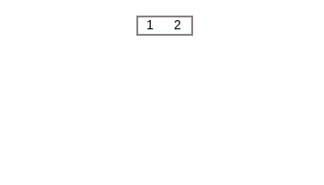Insert > 2

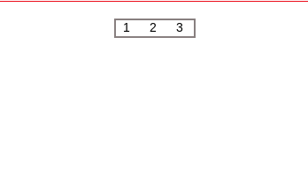Insert > 3

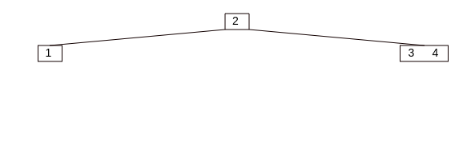Insert > 4

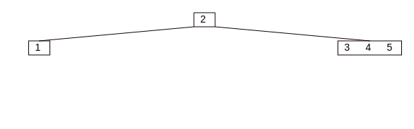Insert > 5

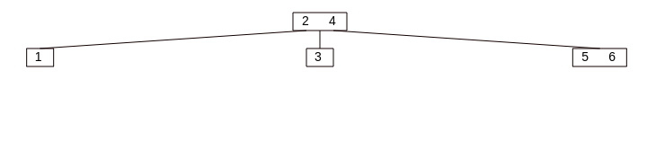Insert > 6

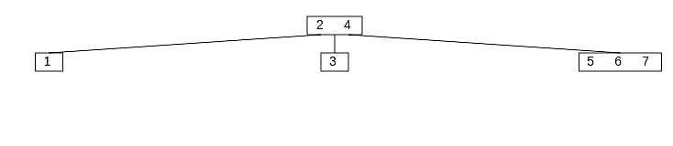Insert > 7

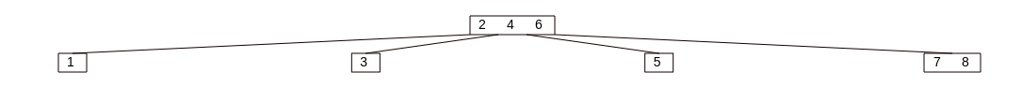Insert > 8

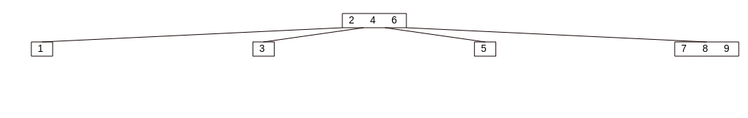Insert > 9

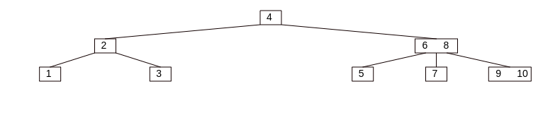Insert > 10

# Delete (Silme)

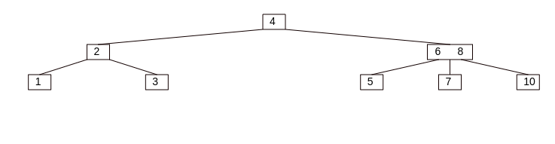Delete > 9

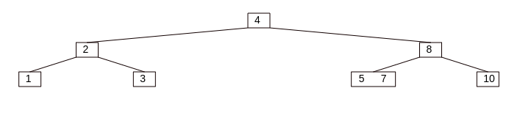Delete > 6

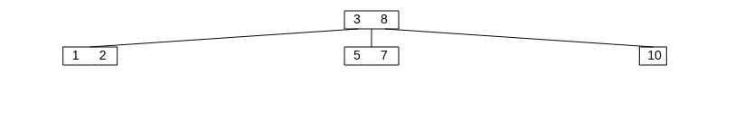Delete > 4